Lab6b Sorting Algorithms
Timing Differences Between QuickSort Variants
There is no significant difference in timings between the standard QuickSort and Hungarian QuickSort. Both algorithms are in the same complexity class (O(n log n) average case), and they both use similar partitioning strategies. The main difference is in how they approach the partitioning - standard QuickSort uses a single pointer moving from left to right, while Hungarian QuickSort uses two pointers moving from both ends. This difference in approach doesn't significantly impact the overall performance since both methods still perform the same number of comparisons and swaps in the average case.
MergeSort vs QuickSort Performance
If MergeSort appears slower than QuickSort, this is actually expected behavior despite both being O(n log n). Here's why:
- MergeSort requires additional memory for temporary arrays during merging
- MergeSort performs more memory operations (copying elements between arrays)
- QuickSort works in-place, meaning it doesn't need extra memory
- QuickSort has better cache utilization due to its in-place nature
- The constant factors in MergeSort's operations are generally larger than QuickSort's
- HPartition Linear Time Complexity
The Hungarian Partition function runs in O(n) time because:
- It uses two pointers (i and j) that move towards each other
- Each element is compared at most once
- The total number of comparisons is bounded by the array size
- Each swap operation is O(1)
- The pointers can never cross each other without meeting
- The algorithm terminates when the pointers meet or cross
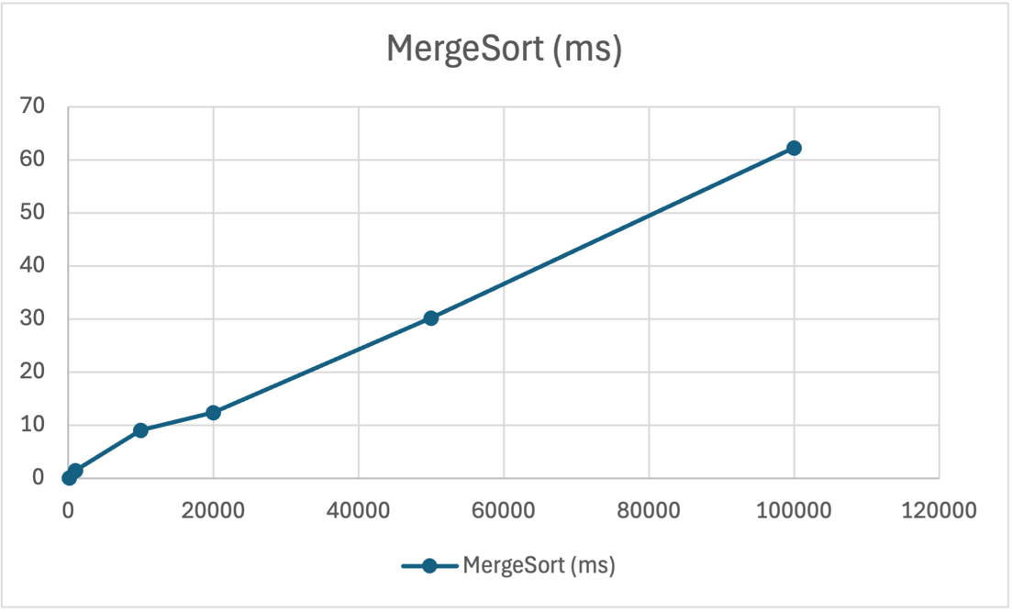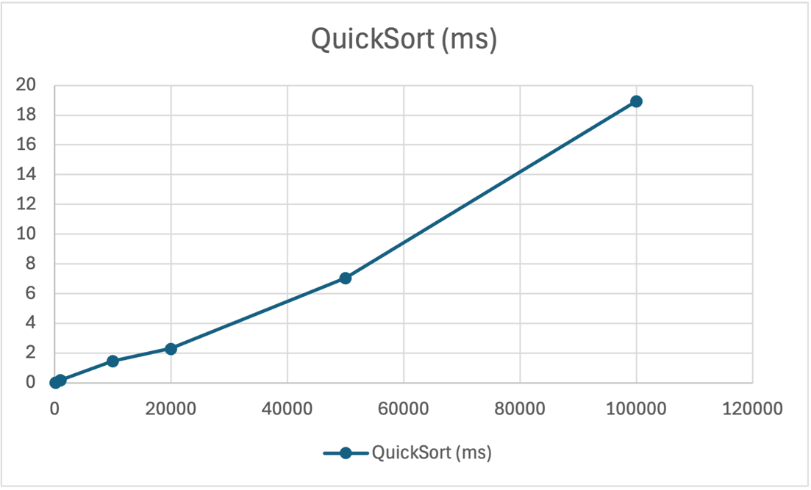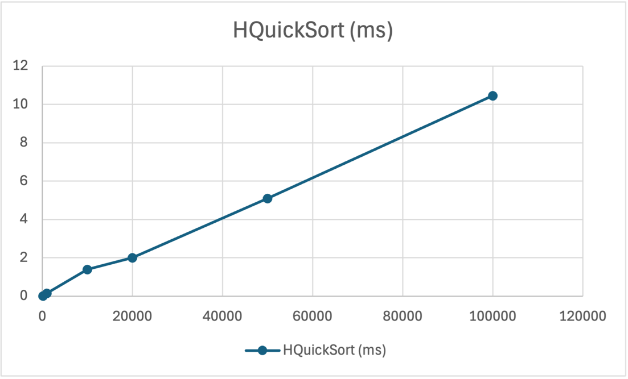

Code Appendix
1. #include <iostream>
2. #include <vector>
3. #include <chrono>
4. #include <fstream>
5. #include <iomanip>
6. #include <cstdlib>
7. #include "Fraction.h"
8. using namespace std;
9.
10. // Simple random number generator
11. int getRandomNumber(int min, int max) {
12. return min + (rand() % (max - min + 1));
13. }
14.
15. // Generate random fractions
16. vector<Fraction> generateRandomFractions(int size) {
17. vector<Fraction> fractions;
18. for (int i = 0; i < size; i++) {
19. int num = getRandomNumber(1, 100);
20. int den = getRandomNumber(1, 100);
21. if (num > den) swap(num, den);
22. fractions.push_back(Fraction(num, den));
23. }
24. return fractions;
25. }
26.
27. // MergeSort functions
28. void merge(vector<Fraction>& arr, int left, int mid, int right) {
29. vector<Fraction> L, R;
30. L.insert(L.begin(), arr.begin() + left, arr.begin() + mid + 1);
31. R.insert(R.begin(), arr.begin() + mid + 1, arr.begin() + right + 1);
32.
33. int i = 0, j = 0, k = left;
34. while (i < L.size() && j < R.size()) {
35. arr[k++] = (L[i] < R[j]) ? L[i++] : R[j++];
36. }
37. while (i < L.size()) arr[k++] = L[i++];
38. while (j < R.size()) arr[k++] = R[j++];
39. }
40.
41. void mergeSortHelper(vector<Fraction>& arr, int left, int right) {
42. if (left < right) {
43. int mid = left + (right - left) / 2;
44. mergeSortHelper(arr, left, mid);
45. mergeSortHelper(arr, mid + 1, right);
46. merge(arr, left, mid, right);
47. }
48. }
49.
50. void mergeSort(vector<Fraction>& arr) {
51. mergeSortHelper(arr, 0, arr.size() - 1);
52. }
53.
54. // QuickSort functions
55. int partition(vector<Fraction>& arr, int low, int high) {
56. Fraction pivot = arr[high];
57. int i = low - 1;
58.
59. for (int j = low; j < high; j++) {
60. if (arr[j] < pivot) {
61. i++;
62. swap(arr[i], arr[j]);
63. }
64. }
65. swap(arr[i + 1], arr[high]);
66. return i + 1;
67. }
68.
69. void quickSortHelper(vector<Fraction>& arr, int low, int high) {
70. if (low < high) {
71. int pi = partition(arr, low, high);
72. quickSortHelper(arr, low, pi - 1);
73. quickSortHelper(arr, pi + 1, high);
74. }
75. }
76.
77. void quickSort(vector<Fraction>& arr) {
78. quickSortHelper(arr, 0, arr.size() - 1);
79. }
80.
81. // Hungarian QuickSort functions
82. int hPartition(vector<Fraction>& arr, int low, int high) {
83. Fraction pivot = arr[low];
84. int i = low;
85. int j = high;
86.
87. while (true) {
88. while (arr[i] < pivot) i++;
89. while (arr[j] > pivot) j--;
90.
91. if (i >= j) return j;
92.
93. swap(arr[i], arr[j]);
94. i++;
95. j--;
96. }
97. }
98.
99. void hQuickSortHelper(vector<Fraction>& arr, int low, int high) {
100. if (low < high) {
101. int pi = hPartition(arr, low, high);
102. hQuickSortHelper(arr, low, pi);
103. hQuickSortHelper(arr, pi + 1, high);
104. }
105. }
106.
107. void hQuickSort(vector<Fraction>& arr) {
108. hQuickSortHelper(arr, 0, arr.size() - 1);
109. }
110.
111. int main() {
112. srand(static_cast<unsigned int>(time(nullptr)));
113.
114. const int NUM_TESTS = 5;
115. const vector<int> SIZES = {100, 1000, 10000, 20000, 50000, 100000};
116. vector<double> mergeTimes(SIZES.size(), 0.0);
117. vector<double> quickTimes(SIZES.size(), 0.0);
118. vector<double> hQuickTimes(SIZES.size(), 0.0);
119.
120. // Run tests for each size
121. for (size_t i = 0; i < SIZES.size(); i++) {
122. for (int test = 0; test < NUM_TESTS; test++) {
123. vector<Fraction> fractions = generateRandomFractions(SIZES[i]);
124.
125. // Time merge sort
126. vector<Fraction> mergeCopy = fractions;
127. chrono::high_resolution_clock::time_point mergeStart = chrono::high_resolution_clock::now();
128. mergeSort(mergeCopy);
129. chrono::high_resolution_clock::time_point mergeEnd = chrono::high_resolution_clock::now();
130. mergeTimes[i] += chrono::duration<double, milli>(mergeEnd - mergeStart).count();
131.
132. // Time quick sort
133. vector<Fraction> quickCopy = fractions;
134. chrono::high_resolution_clock::time_point quickStart = chrono::high_resolution_clock::now();
135. quickSort(quickCopy);
136. chrono::high_resolution_clock::time_point quickEnd = chrono::high_resolution_clock::now();
137. quickTimes[i] += chrono::duration<double, milli>(quickEnd - quickStart).count();
138.
139. // Time Hungarian quick sort
140. vector<Fraction> hQuickCopy = fractions;
141. chrono::high_resolution_clock::time_point hQuickStart = chrono::high_resolution_clock::now();
142. hQuickSort(hQuickCopy);
143. chrono::high_resolution_clock::time_point hQuickEnd = chrono::high_resolution_clock::now();
144. hQuickTimes[i] += chrono::duration<double, milli>(hQuickEnd - hQuickStart).count();
145. }
146.
147. mergeTimes[i] /= NUM_TESTS;
148. quickTimes[i] /= NUM_TESTS;
149. hQuickTimes[i] /= NUM_TESTS;
150. cout << "Done with size " << SIZES[i] << "\n";
151. }
152.
153. // Print results
154. cout << "\nTiming Results:\nSize\tMergeSort (ms)\tQuickSort (ms)\tHQuickSort (ms)\n----------------------------------------\n";
155. for (size_t i = 0; i < SIZES.size(); i++) {
156. cout << SIZES[i] << "\t" << fixed << setprecision(3) << mergeTimes[i] << "\t\t" << quickTimes[i] << "\t\t" << hQuickTimes[i] << "\n";
157. }
158.
159. // Save to CSV
160. ofstream csvFile("sorting_results.csv");
161. if (csvFile.is_open()) {
162. csvFile << "Size,MergeSort (ms),QuickSort (ms),HQuickSort (ms)\n";
163. for (size_t i = 0; i < SIZES.size(); i++) {
164. csvFile << SIZES[i] << "," << fixed << setprecision(3) << mergeTimes[i] << "," << quickTimes[i] << "," << hQuickTimes[i] << "\n";
165. }
166. csvFile.close();
167. cout << "\nResults saved to sorting_results.csv\n";
168. }
169.
170. return 0;
171. }
172.

1. #include "Fraction.h"
2. #include <algorithm>
3. #include <cmath>
4.
5. // Helper function to find GCD
6. int gcd(int a, int b) {
7. a = std::abs(a);
8. b = std::abs(b);
9. while (b) {
10. int temp = b;
11. b = a % b;
12. a = temp;
13. }
14. return a;
15. }
16.
17. Fraction::Fraction() : numerator(0), denominator(1) {}
18.
19. Fraction::Fraction(int num, int den) {
20. if (den == 0) {
21. throw std::invalid_argument("Denominator cannot be zero");
22. }
23.
24. // Ensure denominator is positive
25. if (den < 0) {
26. num = -num;
27. den = -den;
28. }
29.
30. numerator = num;
31. denominator = den;
32. simplify();
33. }
34.
35. int Fraction::getNumerator() const {
36. return numerator;
37. }
38.
39. int Fraction::getDenominator() const {
40. return denominator;
41. }
42.
43. void Fraction::setNumerator(int num) {
44. numerator = num;
45. simplify();
46. }
47.
48. void Fraction::setDenominator(int den) {
49. if (den == 0) {
50. throw std::invalid_argument("Denominator cannot be zero");
51. }
52. denominator = den;
53. simplify();
54. }
55.
56. bool Fraction::operator<(const Fraction& other) const {
57. return (numerator * other.denominator) < (other.numerator * denominator);
58. }
59.
60. bool Fraction::operator>(const Fraction& other) const {
61. return (numerator * other.denominator) > (other.numerator * denominator);
62. }
63.
64. bool Fraction::operator==(const Fraction& other) const {
65. return (numerator * other.denominator) == (other.numerator * denominator);
66. }
67.
68. void Fraction::simplify() {
69. int divisor = gcd(numerator, denominator);
70. if (divisor != 0) {
71. numerator /= divisor;
72. denominator /= divisor;
73. }
74. }
75.
76. double Fraction::toDouble() const {
77. return static_cast<double>(numerator) / denominator;
78. }
79.

